CPHE 222: Organization, Architecture, and Assembly Language
Homework -- Chapter 4A

The single-cycle datapath for the MIPS processor is shown below. Use this figure and the following assumptions to answer the questions that follow.
- Assume that all signals have propagated through the hardware, but the next clock cycle has not occurred yet.
- Every register has the initial value 10_{ten} times the register number.
- Every memory word accessed as data has the initial value 0x1000 plus the byte address of the word.

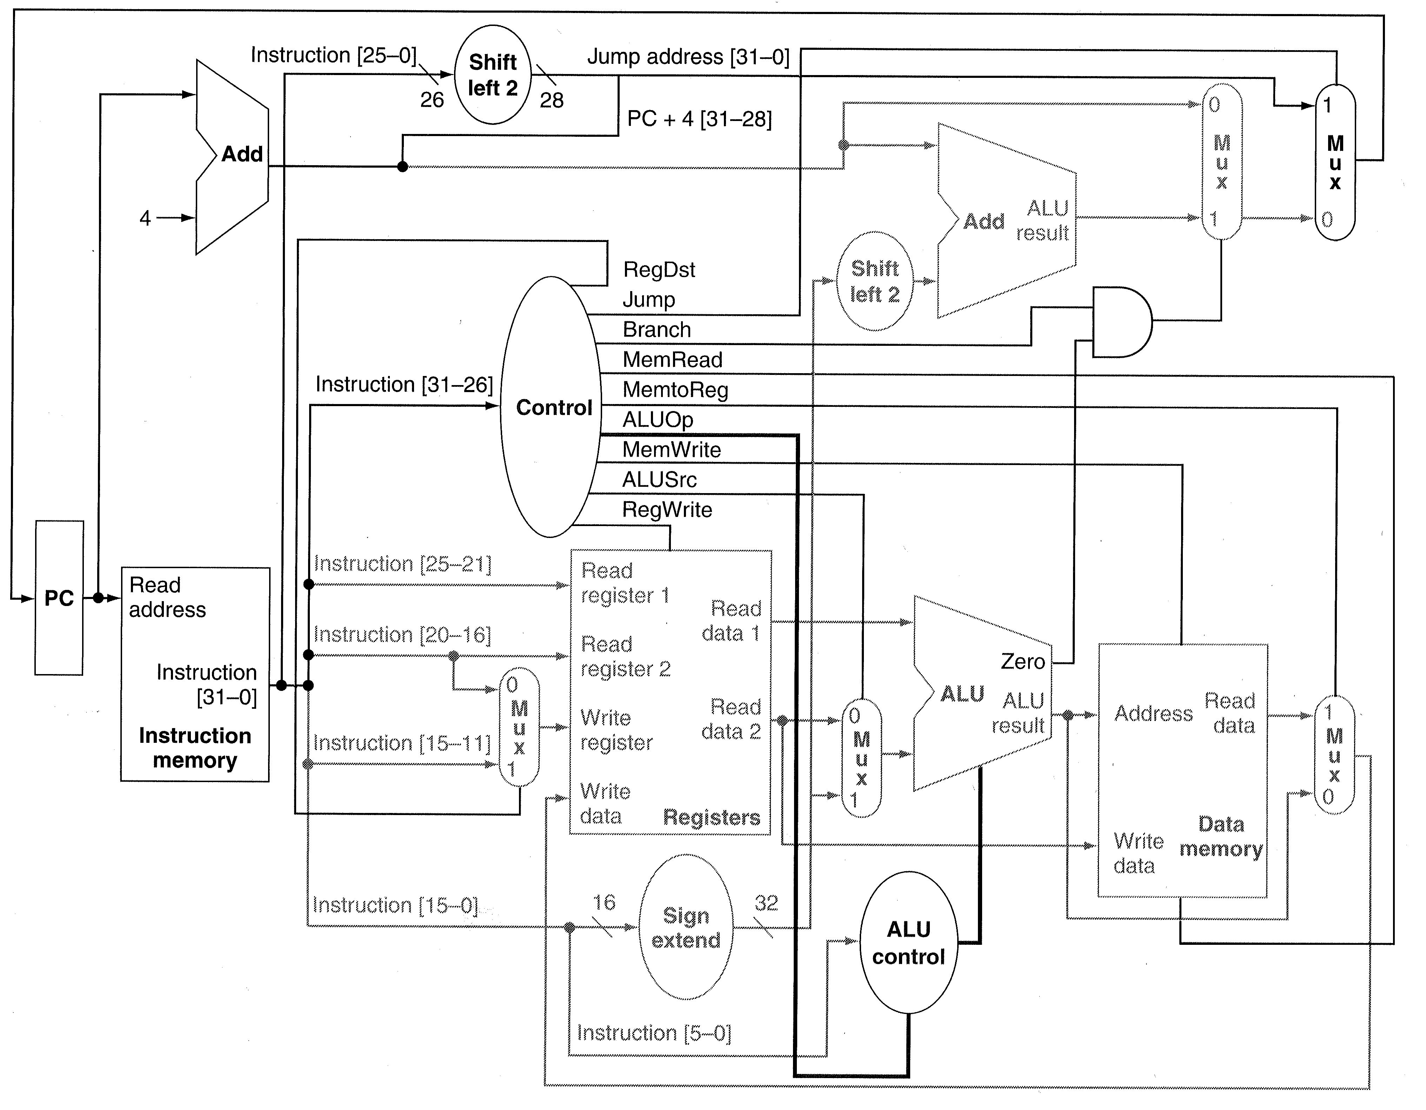

Exercise 1. Fill in the tables below for the instruction “ori $t0, $s1, 0x0084”

Control Signal | Value
RegDst
ALUSrc
MemtoReg
RegWrite
MemRead
MemWrite
Branch
Jump

Data Signal | Value  (32-bit values in Hex and  all other values in binary)
Read Register 1
Read Register 2
Write Register
Read Data 1
Read Data 2
Sign Ext. Immediate
ALU Operation
ALU Result
Register Write Data

Exercise 2. Fill in the tables below for the instruction “sw $ra, 10( $sp )”

Control Signal | Value
RegDst
ALUSrc
MemtoReg
RegWrite
MemRead
MemWrite
Branch
Jump

Data Signal | Value  (32-bit values in Hex and  all other values in binary)
Read Register 1
Read Register 2
Write Register
Read Data 1
Read Data 2
Sign Ext. Immediate
ALU Operation
ALU Result
Memory Write Data

Exercise 3. Fill in the tables below for the instruction “add $v0, $a0, $t1”

Control Signal | Value
RegDst
ALUSrc
MemtoReg
RegWrite
MemRead
MemWrite
Branch
Jump

Data Signal | Value  (32-bit values in Hex and  all other values in binary)
Read Register 1
Read Register 2
Write Register
Read Data 1
Read Data 2
Sign Ext. Immediate
ALU Operation
ALU Result
Memory Write Data

Exercise 4. Fill in the tables below for the instruction “bne $t0, $a1, label1.” Assume that label1 is 5 instructions before the bne instruction.

Control Signal | Value
RegDst
ALUSrc
MemtoReg
RegWrite
MemRead
MemWrite
Branch
Jump

Data Signal | Value  (32-bit values in Hex and  all other values in binary)
Read Register 1
Read Register 2
Write Register
Read Data 1
Read Data 2
Sign Ext. Immediate
ALU Operation
ALU Result
Memory Write Data

Exercise 5. The single-cycle datapath for the MIPS processor is shown below. As shown, this hardware does not support the jal instruction. Modify the diagram to add support for this instruction and specify the values for the control signals for this instruction. Add any new control signals you create to the table in the blanks provided.

Control Signal | Value
RegDst
ALUSrc
MemtoReg
RegWrite
MemRead
MemWrite
Branch
Jump
Exercise 6. The single-cycle datapath for the MIPS processor is shown below. As shown, this hardware does not support the jr instruction. Modify the diagram to add support for this instruction and specify the values for the control signals for this instruction. Add any new control signals you create to the table in the blanks provided.

Control Signal | Value
RegDst
ALUSrc
MemtoReg
RegWrite
MemRead
MemWrite
Branch
Jump

